Output of Lab 1.1

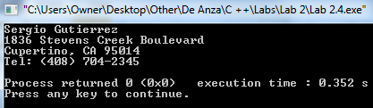

Output of Lab 2.2

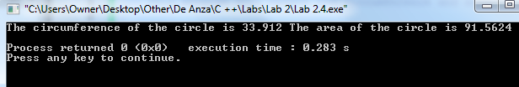

Output of Lab 2.3

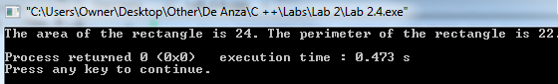

Output of Lab 2.4

